**ONLINE HOTEL RESERVATION PROJECT**

**CS 631 – Database Management System Design**

**Katie Perkins**

**Sudhan Rameshwaran**

**Yusuf Sabuwala**

**Phase 3 Goals**

The Phase 3 goal of the Hotel Reservation Project is to translate our Relational Schema to a database framework, and populate the database, to create a functional website which is a menu driven application system for the Hulton chain of hotels.

**Description of Implementation**

To create our databases, we used MySQL Workbench and Navicat. We first created the tables including primary, secondary, and foreign keys, and then we created SQL command files to populate each table. Refer to the Source Code in #5 for a sql file of the database. The menu driven interface application system is created with Visual Studio, and a .net framework.

**Problems Faced**

The challenging aspect was creating a menu driven application system. We were unsure what route to use for the interface, and ultimately decided on a .net framework. Our first approach to the solution involved using Eclipse

Another challenge faced during the creation of the tables, the credit card number was implemented as an integer and only allowed a certain amount of characters. The only way to fix this would be to delete the entire table and recreate it due to the constraints.

**User Guide**

The customer will be able to securely log on with a username and password or select Register and will be brought to a new screen to collect information. If the customer is registering for the site, they will be asked to provide a username, password, address, phone number, and email. This information on the customer will then be stored in the customer table.

To make a reservation, the customer may search for the country and state, the interface will then provide a list of hotels that match this criterion. The customer may then click into a hotel and will enter to a new screen to provide more information. In this screen the customer may select the room type, the check in/ check out date, etc. In this screen, the customer can also view if a discount exists for the room. On top of considering the discount on the room, the total amount of the reservation is calculated by adding the sum of the costs of all breakfast orders, the sum of the costs for all the services ordered and the sum of the cost of the different rooms included in the reservation.

A screen for reservation statistics will also be available for Hulton to analyze customer satisfaction and need. The statistics will show the highest rated room type for each hotel, the 5 best customers (in terms of money spent in reservations), the highest rated breakfast type across all hotels, and the highest rated service types across all hotels. These statistics will all be based on a begin/ end date as provided by the analyst.

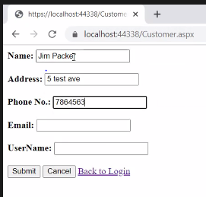

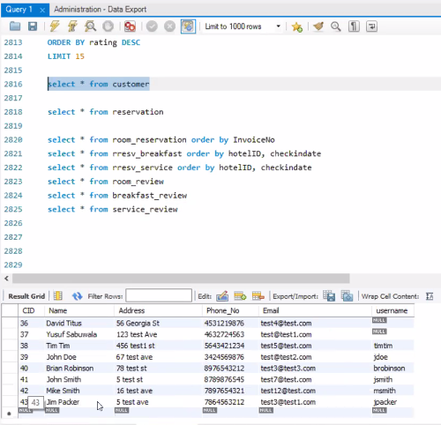

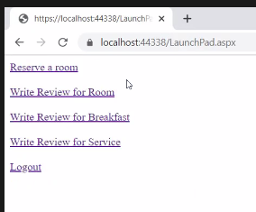

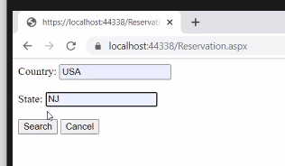

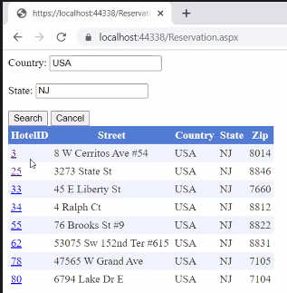

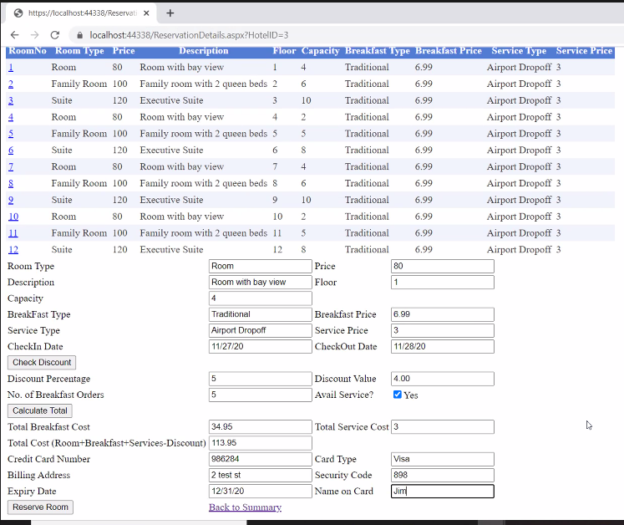

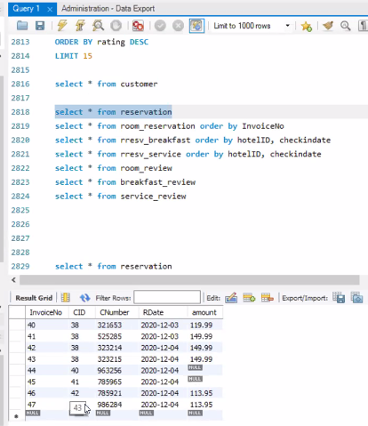

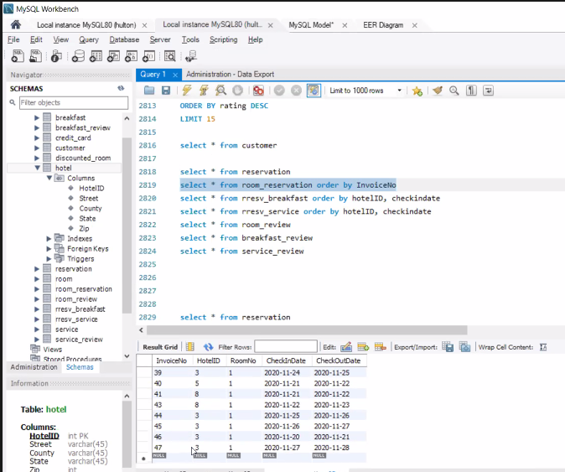

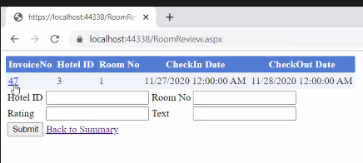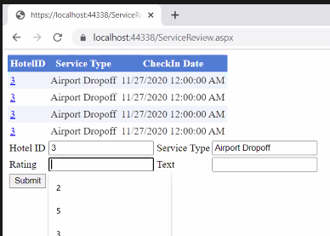

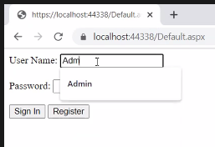

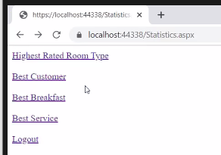

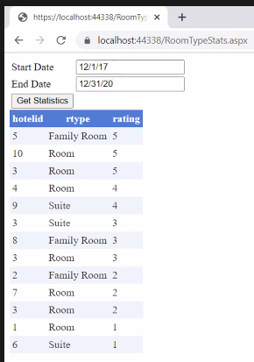

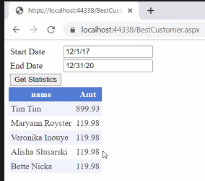

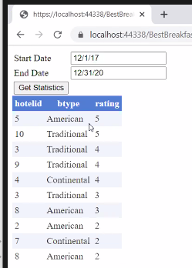

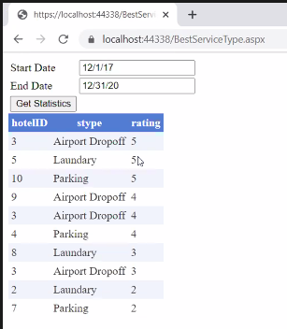

**SQL Commands (Table Creation):**

DROP TABLE IF EXISTS hotel;

CREATE TABLE hotel (

hotel_id int(11) NOT NULL,

street varchar(255) NOT NULL,

country varchar(255) NOT NULL,

state varchar(255) NOT NULL,

zip varchar(255) NOT NULL,

PRIMARY KEY(hotel_id)

) ENGINE=InnoDB DEFAULT CHARSET=utf8;

DROP TABLE IF EXISTS breakfast;   
CREATE TABLE breakfast ( hotel_id int(11) NOT NULL,   
b_type varchar(255) NOT NULL,   
b_price int(11) NOT NULL,   
description varchar(255) NOT NULL,   
PRIMARY KEY (hotel_id,b_type),   
CONSTRAINT breakfast_ibfk_1  
FOREIGN KEY (hotel_id) REFERENCES hotel (hotel_id)   
ON DELETE CASCADE ON UPDATE CASCADE )   
ENGINE=InnoDB DEFAULT CHARSET=utf8;

DROP TABLE IF EXISTS customer;   
CREATE TABLE customer ( c_id int(11) NOT NULL,   
name varchar(255) NOT NULL,   
address varchar(255) NOT NULL,   
phone varchar(255) NOT NULL,   
email varchar(255) NOT NULL,   
password varchar(255) NOT NULL,   
PRIMARY KEY (c_id) )   
ENGINE=InnoDB DEFAULT CHARSET=utf8;

DROP TABLE IF EXISTS breakfast_review;  
CREATE TABLE breakfast_review (  
r_id int(11) NOT NULL AUTO_INCREMENT,  
hotel_id int(11) NOT NULL,  
b_type varchar(255) NOT NULL,  
c_id int(11) NOT NULL,  
text varchar(255) NOT NULL,  
rating double NOT NULL,  
rdate datetime NOT NULL,  
PRIMARY KEY (r_id),  
KEY breakfase_review_ibfk_2 (hotel_id,b_type),  
KEY c_id (c_id),  
CONSTRAINT breakfast_review_ibfk_2   
FOREIGN KEY (hotel_id, b_type) REFERENCES  
breakfast (hotel_id, b_type)   
ON DELETE CASCADE ON UPDATE CASCADE,  
CONSTRAINT breakfast_review_ibfk_3   
FOREIGN KEY (c_id) REFERENCES customer (c_id)  
ON DELETE CASCADE ON UPDATE CASCADE  
) ENGINE=InnoDB AUTO_INCREMENT=3001 DEFAULT CHARSET=utf8;

DROP TABLE IF EXISTS credit_card;   
CREATE TABLE credit_card (   
c_number varchar(255) NOT NULL,   
c_type varchar(255) NOT NULL,   
baddress varchar(255) NOT NULL,   
code int(11) NOT NULL,   
exp_date datetime NOT NULL,   
name varchar(255) NOT NULL,   
c_id int(11) NOT NULL,   
PRIMARY KEY (c_number),   
KEY c_id (c_id),   
CONSTRAINT credit_card_ibfk_1 FOREIGN KEY (c_id) REFERENCES customer (c_id) ON DELETE CASCADE ON UPDATE CASCADE )   
ENGINE=InnoDB DEFAULT CHARSET=utf8;

DROP TABLE IF EXISTS reservation;   
CREATE TABLE reservation (   
invoice_no varchar(255) NOT NULL,   
c_id int(11) NOT NULL,   
c_number varchar(255) NOT NULL,   
r_date datetime(6) NOT NULL,   
amount int(11) NOT NULL,   
PRIMARY KEY (invoice_no), KEY c_id (c_id),   
KEY c_number (c_number),   
CONSTRAINT reservation_ibfk_2 FOREIGN KEY (c_id) REFERENCES customer (c_id) ON DELETE CASCADE ON UPDATE CASCADE,   
CONSTRAINT reservation_ibfk_3 FOREIGN KEY (c_number) REFERENCES credit_card (c_number) ON DELETE CASCADE ON UPDATE CASCADE )   
ENGINE=InnoDB DEFAULT CHARSET=utf8;

DROP TABLE IF EXISTS room;   
CREATE TABLE room (   
hotel_id int(11) NOT NULL,   
room_no int(11) NOT NULL,   
rtype varchar(255) NOT NULL,   
price int(11) NOT NULL,   
floor int(11) NOT NULL,   
capacity int(11) NOT NULL,   
room_description varchar(255) NOT NULL,   
PRIMARY KEY (hotel_id,room_no),   
CONSTRAINT room_ibfk_1 FOREIGN KEY (hotel_id) REFERENCES hotel (hotel_id) ON DELETE CASCADE ON UPDATE CASCADE )   
ENGINE=InnoDB DEFAULT CHARSET=utf8;

DROP TABLE IF EXISTS room_reservation;   
CREATE TABLE room_reservation (   
invoice_no varchar(255) NOT NULL,   
hotel_id int(11) NOT NULL,   
room_no int(11) NOT NULL,   
check_in_date datetime NOT NULL,   
check_out_date datetime NOT NULL,   
PRIMARY KEY (hotel_id,room_no,check_in_date),   
KEY invoice_no (invoice_no),   
CONSTRAINT room_reservation_ibfk_1 FOREIGN KEY (hotel_id, room_no) REFERENCES room (hotel_id, room_no) ON DELETE CASCADE ON UPDATE CASCADE,   
CONSTRAINT room_reservation_ibfk_2 FOREIGN KEY (invoice_no) REFERENCES reservation (invoice_no) ON DELETE CASCADE ON UPDATE CASCADE )   
ENGINE=InnoDB DEFAULT CHARSET=utf8;

DROP TABLE IF EXISTS discount_room;   
CREATE TABLE discount_room (   
hotel_id int(11) NOT NULL,   
room_no int(11) NOT NULL,   
discount double NOT NULL,   
start_date varchar(255) NOT NULL,   
end_date varchar(255) NOT NULL,   
PRIMARY KEY (hotel_id,room_no),   
CONSTRAINT discount_room_ibfk_1   
FOREIGN KEY (hotel_id, room_no) REFERENCES room (hotel_id, room_no) ON DELETE CASCADE ON UPDATE CASCADE )   
ENGINE=InnoDB DEFAULT CHARSET=utf8;

DROP TABLE IF EXISTS room_review;   
CREATE TABLE room_review (   
rid int(11) NOT NULL AUTO_INCREMENT,   
rating int(11) NOT NULL, text varchar(255) NOT NULL,   
cid int(11) NOT NULL, hotel_id int(11) NOT NULL,   
room_no int(11) NOT NULL,   
rdate datetime DEFAULT NULL,   
PRIMARY KEY (rid), KEY room_review_ibfk_1 (hotel_id,room_no),   
KEY cid (cid),   
CONSTRAINT room_review_ibfk_1 FOREIGN KEY (hotel_id, room_no) REFERENCES room (hotel_id, room_no) ON DELETE CASCADE ON UPDATE CASCADE,   
CONSTRAINT room_review_ibfk_2 FOREIGN KEY (cid) REFERENCES customer (c_id) ON DELETE CASCADE ON UPDATE CASCADE )   
ENGINE=InnoDB AUTO_INCREMENT=3001 DEFAULT CHARSET=utf8;

DROP TABLE IF EXISTS rresv_breakfast;   
CREATE TABLE rresv_breakfast (   
hotel_id int(11) NOT NULL,   
b_type varchar(255) NOT NULL,   
room_no int(11) NOT NULL,   
check_in_date datetime NOT NULL,   
no_of_orders int(255) NOT NULL,   
PRIMARY KEY (b_type,hotel_id,room_no,check_in_date),   
KEY rresv_breakfast_ibfk_1 (hotel_id,b_type),   
KEY hotel_id (hotel_id,room_no,check_in_date),   
CONSTRAINT rresv_breakfast_ibfk_1 FOREIGN KEY (hotel_id, b_type) REFERENCES breakfast (hotel_id, b_type) ON DELETE CASCADE ON UPDATE CASCADE,   
CONSTRAINT rresv_breakfast_ibfk_2 FOREIGN KEY (hotel_id, room_no, check_in_date) REFERENCES room_reservation (hotel_id, room_no, check_in_date) ON DELETE CASCADE ON UPDATE CASCADE )   
ENGINE=InnoDB DEFAULT CHARSET=utf8;

DROP TABLE IF EXISTS service;   
CREATE TABLE service (   
hotel_id int(11) NOT NULL,   
s_type varchar(255) NOT NULL,   
s_price int(11) NOT NULL,   
PRIMARY KEY (hotel_id,s_type), CONSTRAINT service_ibfk_1 FOREIGN KEY (hotel_id) REFERENCES hotel (hotel_id) ON DELETE CASCADE ON UPDATE CASCADE )   
ENGINE=InnoDB DEFAULT CHARSET=utf8;

DROP TABLE IF EXISTS rresv_service;   
CREATE TABLE rresv_service ( hotel_id int(11) NOT NULL,   
s_type varchar(255) NOT NULL,   
room_no int(11) NOT NULL,   
check_in_date datetime NOT NULL,   
PRIMARY KEY (s_type,hotel_id,room_no,check_in_date),   
KEY rresv_service_ibfk_1 (hotel_id,s_type),   
KEY hotel_id (hotel_id,room_no,check_in_date),   
CONSTRAINT rresv_service_ibfk_1 FOREIGN KEY (hotel_id, s_type) REFERENCES service (hotel_id, s_type) ON DELETE CASCADE ON UPDATE CASCADE,   
CONSTRAINT rresv_service_ibfk_2 FOREIGN KEY (hotel_id, room_no, check_in_date) REFERENCES room_reservation (hotel_id, room_no, check_in_date) ON DELETE CASCADE ON UPDATE CASCADE )   
ENGINE=InnoDB DEFAULT CHARSET=utf8;

DROP TABLE IF EXISTS service_review;   
CREATE TABLE service_review (   
r_id int(11) NOT NULL AUTO_INCREMENT,   
hotel_id int(11) NOT NULL,   
s_type varchar(255) NOT NULL,   
c_id int(11) NOT NULL, rating double NOT NULL,   
text varchar(255) NOT NULL,   
rdate datetime NOT NULL, PRIMARY KEY (r_id),   
KEY service_review_ibfk_2 (hotel_id,s_type),   
KEY c_id (c_id), CONSTRAINT service_review_ibfk_2 FOREIGN KEY (hotel_id, s_type) REFERENCES service (hotel_id, s_type) ON DELETE CASCADE ON UPDATE CASCADE,   
CONSTRAINT service_review_ibfk_3 FOREIGN KEY (c_id) REFERENCES customer (c_id) ON DELETE CASCADE ON UPDATE CASCADE )   
ENGINE=InnoDB AUTO_INCREMENT=3001 DEFAULT CHARSET=utf8;

**SQL Commands (Populate Tables):**INSERT INTO hotel VALUES ('0', 'street0', 'country0', 'state0', '07029';   
INSERT INTO hotel VALUES ('1', 'street1', 'country1', 'state1', '07030';   
INSERT INTO hotel VALUES ('2', 'street2', 'country2', 'state2', '07031');   
INSERT INTO hotel VALUES ('3', 'street3', 'country3', 'state3', '07032');  
INSERT INTO hotel VALUES ('4', 'street4', 'country4', 'state4', '07033');

INSERT INTO breakfast VALUES ('0', 'American', '160', 'American');   
INSERT INTO breakfast VALUES ('0', 'Continental', '110', 'Continental');   
INSERT INTO breakfast VALUES ('0', 'English', '220', 'English');   
INSERT INTO breakfast VALUES ('0', 'French', '230', 'French');   
INSERT INTO breakfast VALUES ('0', 'Italian', '260', 'Italian');   
INSERT INTO breakfast VALUES ('1', 'American', '170', 'American');  
INSERT INTO breakfast VALUES ('1', 'Italian', '280', 'Italian');   
INSERT INTO breakfast VALUES ('1', 'English', '225', 'English');  
INSERT INTO breakfast VALUES ('2', 'Italian', '280', 'Italian');   
INSERT INTO breakfast VALUES ('2', 'English', '225', 'English');   
INSERT INTO breakfast VALUES ('2', 'French', '232', 'French');   
INSERT INTO breakfast VALUES ('3', 'Italian', '285', 'Italian');   
INSERT INTO breakfast VALUES ('3', 'English', '226', 'English');   
INSERT INTO breakfast VALUES ('3', 'French', '233', 'French');   
INSERT INTO breakfast VALUES ('4', 'Italian', '285', 'Italian');   
INSERT INTO breakfast VALUES ('4', 'English', '256', 'English');   
INSERT INTO breakfast VALUES ('4', 'French', '243', 'French');

INSERT INTO customer VALUES ('0', 'customer0', 'street0', '12345678901', 'Test12345@gmail.com', 'p0');   
INSERT INTO customer VALUES ('1', 'customer1', 'street1', '23456789012', 'Test23456@gmail.com', 'p1');   
INSERT INTO customer VALUES ('2', 'customer2', 'street2', '34567890123', 'Test34567@gmail.com', 'p2');   
INSERT INTO customer VALUES ('3', 'customer3', 'street3', '45678901234', 'Test45678@gmail.com', 'p3');  
INSERT INTO customer VALUES ('4', 'customer4', 'street4', '56789012345', 'Test55678@gmail.com', 'p4');

INSERT INTO credit_card VALUES ('1017258780368178', 'Discover', 'address01', '535', '2025-04-03 00:00:00', 'c410', '0');   
INSERT INTO credit_card VALUES ('1043210066621620', 'Amex', 'address02', '539', '2025-04-03 00:00:00', 'c450', '2');   
INSERT INTO credit_card VALUES ('1052634640785415', 'Discover', 'address17', '692', '2025-04-03 00:00:00', 'c389', '3');   
INSERT INTO credit_card VALUES ('1066565136632600', 'Master', 'address62', '456', '2025-04-03 00:00:00', 'c129', '1');

INSERT INTO reservation VALUES ('1400655115772624', '0', '1017258780368178', '2020-10-29 09:29:17.000000', '510');   
INSERT INTO reservation VALUES ('7389753215178781', '2', '1043210066621620', '2020-10-29 09:29:17.000000', '560');   
INSERT INTO reservation VALUES ('2534397781775065', '3', '1052634640785415', '2020-10-29 09:29:17.000000', '560');   
INSERT INTO reservation VALUES ('8668629889848350', '1', '1066565136632600', '2020-10-29 09:29:17.000000', '621');

INSERT INTO breakfast_review VALUES ('3001', '1', 'American', '0', 'Breakfast Review', '7', '2020-10-29 09:29:17');   
INSERT INTO breakfast_review VALUES ('3002', '2', 'English', '1', 'Breakfast Review', '10', '2020-10-29 09:29:17');   
INSERT INTO breakfast_review VALUES ('3003', '3', 'French', '2', 'Breakfast Review', '7', '2020-10-29 09:29:17');   
INSERT INTO breakfast_review VALUES ('3004', '4', 'Italian', '3', 'Breakfast Review', '9', '2020-10-29 09:29:17');

INSERT INTO room VALUES ('0', '1', 'standard', '300', '1', '1', 'standard');   
INSERT INTO room VALUES ('0', '2', 'suite', '600', '2', '4', 'suite');   
INSERT INTO room VALUES ('0', '3', 'deluxe', '500', '3', '3', 'deluxe');   
INSERT INTO room VALUES ('0', '4', 'standard', '300', '4', '1', 'standard');   
INSERT INTO room VALUES ('0', '5', 'standard', '300', '0', '1', 'standard');   
INSERT INTO room VALUES ('1', '1', 'deluxe', '500', '1', '3', 'deluxe');   
INSERT INTO room VALUES ('1', '2', 'deluxe', '500', '2', '3', 'deluxe');   
INSERT INTO room VALUES ('1', '3', 'suite', '600', '3', '4', 'suite');

INSERT INTO discount_room VALUES ('0', '1', '0.98', '2020-10-20', '2020-06-13');   
INSERT INTO discount_room VALUES ('0', '2', '0.99', '2020-08-08', '2020-10-16');   
INSERT INTO discount_room VALUES ('0', '3', '0.9', '2020-02-05', '2020-10-10');   
INSERT INTO discount_room VALUES ('0', '4', '0.8', '2020-10-24', '2020-12-06');   
INSERT INTO discount_room VALUES ('0', '5', '0.8560000000000001', '2020-10-14', '2020-12-23');

INSERT INTO room_reservation VALUES ('1400655115772624', '1', '1', '2020-10-02 00:00:00', '2020-10-03 00:00:00');   
INSERT INTO room_reservation VALUES ('2534397781775065', '1', '2', '2020-10-06 00:00:00', '2020-10-07 00:00:00');   
INSERT INTO room_reservation VALUES ('7389753215178781', '1', '3', '2020-10-10 00:00:00', '2020-10-11 00:00:00');  
INSERT INTO room_reservation VALUES ('8668629889848350', '1', '2', '2020-10-14 00:00:00', '2020-10-15 00:00:00');

INSERT INTO room_review VALUES ('3001', '1', 'roomreview', '0', '1', '1', '2020-10-29 09:29:17');   
INSERT INTO room_review VALUES ('3002', '9', 'roomreview', '1', '2', '2', '2020-10-29 09:29:17');   
INSERT INTO room_review VALUES ('3003', '10', 'roomreview', '2', '3', '3', '2020-10-29 09:29:17');   
INSERT INTO room_review VALUES ('3010', '10', 'roomreview', '3', '4', '4', '2020-10-29 09:29:17');   
INSERT INTO room_review VALUES ('3005', '7', 'roomreview', '4', '5', '5', '2020-10-29 09:29:17');

INSERT INTO rresv_breakfast VALUES ('1', 'American', '1', '2020-10-02 00:00:00', '1');   
INSERT INTO rresv_breakfast VALUES ('1', 'American', '2', '2020-10-06 00:00:00', '1');  
INSERT INTO rresv_breakfast VALUES ('1', 'Italian', '2', '2020-10-14 00:00:00', '1');   
INSERT INTO rresv_breakfast VALUES ('1', 'English', '3', '2020-10-10 00:00:00', '1');

INSERT INTO service VALUES ('0', 'airport-drop-off', '21');   
INSERT INTO service VALUES ('0', 'airport-pick-up', '21');   
INSERT INTO service VALUES ('0', 'laundry', '13');   
INSERT INTO service VALUES ('0', 'parking', '10');   
INSERT INTO service VALUES ('1', 'airport-drop-off', '21');   
INSERT INTO service VALUES ('1', 'airport-pick-up', '21');   
INSERT INTO service VALUES ('1', 'laundry', '13');   
INSERT INTO service VALUES ('1', 'parking', '10');  
INSERT INTO service VALUES ('2', 'airport-drop-off', '22');   
INSERT INTO service VALUES ('2', 'airport-pick-up', '22');   
INSERT INTO service VALUES ('2', 'laundry', '12.5');   
INSERT INTO service VALUES ('2', 'parking', '11');  
INSERT INTO service VALUES ('3', 'airport-drop-off', '20');   
INSERT INTO service VALUES ('3', 'airport-pick-up', '20');   
INSERT INTO service VALUES ('3', 'laundry', '11');   
INSERT INTO service VALUES ('3', 'parking', '11');

INSERT INTO rresv_service VALUES ('1', 'parking', '1', '2020-10-02 00:00:00');  
INSERT INTO rresv_service VALUES ('1', 'airport-drop-off', '2', '2020-10-06 00:00:00');  
INSERT INTO rresv_service VALUES ('1', 'airport-drop-off', '2', '2020-10-14 00:00:00');  
INSERT INTO rresv_service VALUES ('1', 'airport-drop-off', '3', '2020-10-10 00:00:00');  
INSERT INTO rresv_service VALUES ('1', 'airport-pick-up', '2', '2020-10-14 00:00:00');

INSERT INTO service_review VALUES ('3002', '2', 'parking', '1', '5', 'service review', '2020-12-29 09:29:17');   
INSERT INTO service_review VALUES ('3003', '3', 'airport-drop-off', '2', '3', 'service review', '2020-12-29 09:29:17');  
INSERT INTO service_review VALUES ('3012', '1', 'laundry', '3', '5', 'service review', '2020-12-29 09:29:17');   
INSERT INTO service_review VALUES ('3005', '2', 'airport-pick-up', '4', '2', 'service review', '2020-12-29 09:29:17');   
INSERT INTO service_review VALUES ('3006', '3', 'parking', '5', '9', 'service review', '2020-12-29 09:29:17');

**Source Code:**

Refer to HR.zip below for table populations, and SQL structure.

**A printout of the use of the program:**